# Setting up the Polygon Network

VIDEO

As the crypto world constantly grows, so does the number of networks.

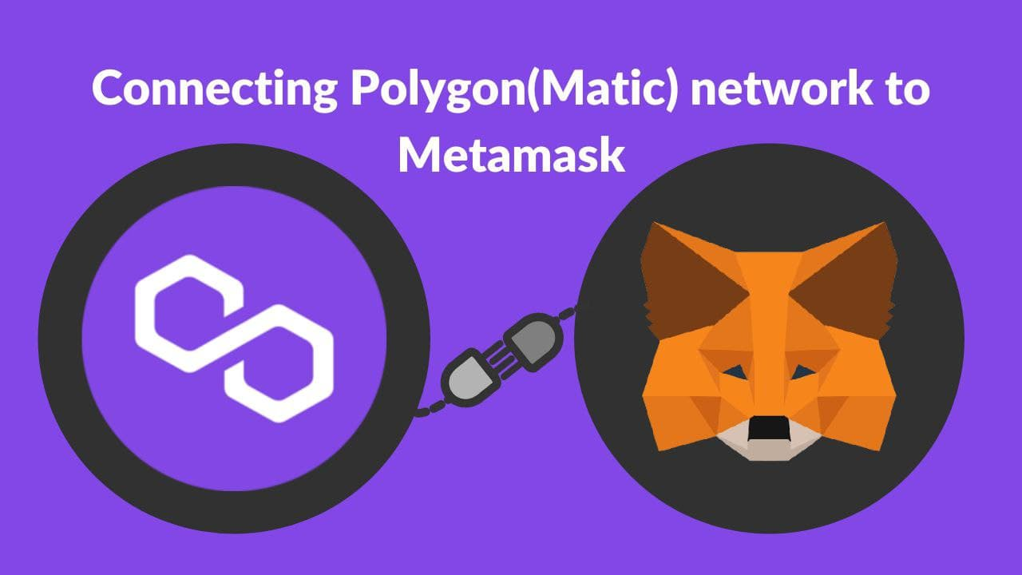

In this article, we will guide you on how to set up the Polygon Network on the MetaMask wallet.

Just in case you aren’t familiar yet: Polygon Network (formerly known as MATIC) is a scaling solution that aims to provide tools that improve the speed, and reduce the cost and complexities of transactions in the blockchain.

#### How to set up the Polygon Network on your MetaMask wallet

You will need the following details about the Polygon Network:

* Network Name: Polygon Network
* New RPC URL: <https://polygon-rpc.com/>
* Chain ID: 137
* Currency Symbol (optional): MATIC
* Block Explorer URL (optional): <https://polygonscan.com/>

Now, let’s go through it step-by-step.

1. Open your MetaMask wallet and hit the button on the top-right corner.

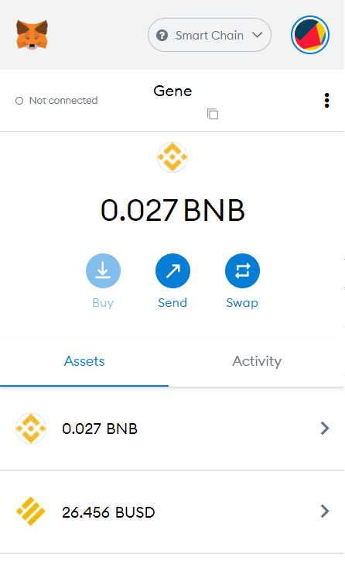

2. Choose Settings in the menu.

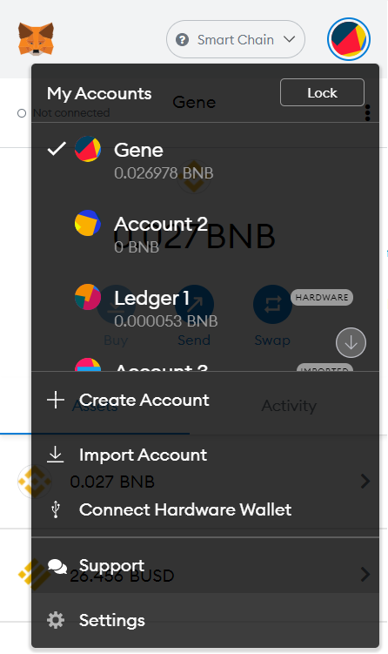

3. Scroll down and click on Networks.

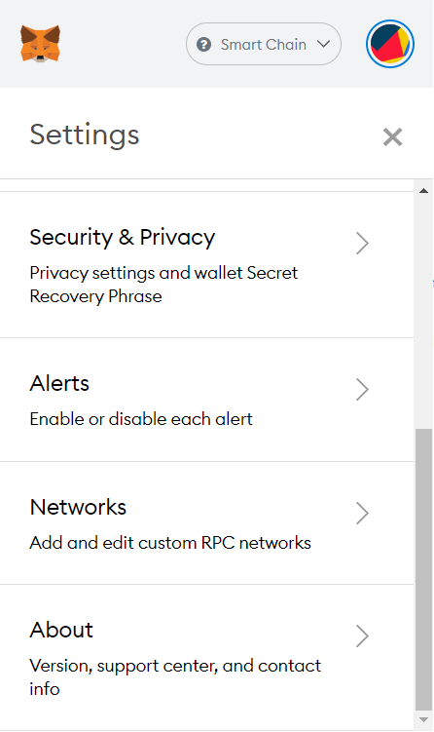

4. Now, you should see a list of networks. Click on Add Network below to add a custom network.

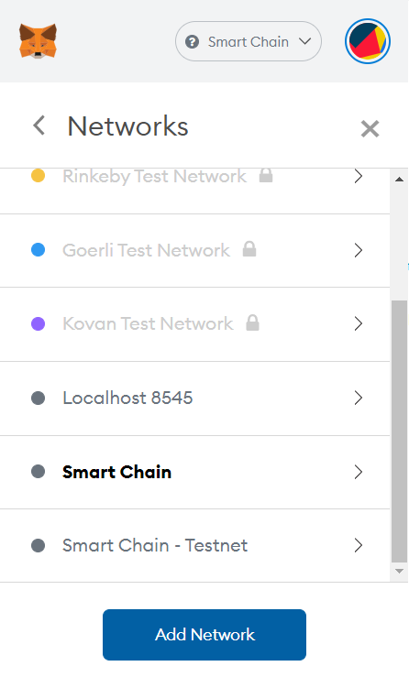

5. Next, fill the fields with the necessary information about the Polygon Network

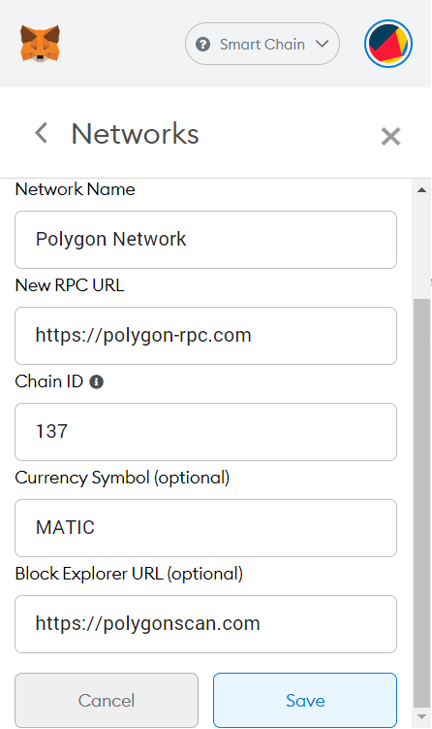

And you’ve just set up the Polygon (MATIC) Network on your MetaMask wallet!

